Configuring GRE Point-

To-Point Tunnels

Ronique Young

2/23/2025

Click the Packet Tracer PKT File to See the Full Configuration

To establish connectivity between the two routers, I configured a GRE (Generic Routing Encapsulation) tunnel, labeled as Tunnel 1, on each router. The tunnel uses the IPv4 subnet 10.10.10.0/30, with R1 assigned the IP address 10.10.10.1/30 and R2 assigned 10.10.10.2/30. This setup follows the network diagram provided.

For both routers, I applied the following settings:

- Set the tunnel source to interface G0/0/0, which is the local router’s outgoing interface.

- Set the tunnel destination to the other router’s G0/0/0 interface IP address (172.16.1.2 for R1 pointing to R2, and 172.16.1.1 for R2 pointing to R1).

- Configured the tunnel mode to GRE over IP to enable encapsulation of packets.

The configuration was implemented as follows:

On R1:

- Entered global configuration mode and created Tunnel 1.

- Assigned the IP address 10.10.10.1 with a subnet mask of 255.255.255.252.

- Specified G0/0/0 as the tunnel source.

- Set the tunnel destination to 172.16.1.2 (R2’s G0/0/0 interface).

- Enabled GRE encapsulation with the "tunnel mode gre ip" command.

On R2:

- Entered global configuration mode and created Tunnel 1.

- Assigned the IP address 10.10.10.2 with a subnet mask of 255.255.255.252.

- Specified G0/0/0 as the tunnel source.

- Set the tunnel destination to 172.16.1.1 (R1’s G0/0/0 interface).

- Enabled GRE encapsulation with the "tunnel mode gre ip" command.

This configuration successfully establishes a GRE tunnel between R1 and R2, allowing encapsulated traffic to flow between the two routers over the specified interfaces.

To establish connectivity between the two routers, I configured a GRE (Generic Routing Encapsulation) tunnel, labeled as Tunnel 1, on each router. The tunnel uses the IPv4 subnet 10.10.10.0/30, with R1 assigned the IP address 10.10.10.1/30 and R2 assigned 10.10.10.2/30, as per the network diagram.

For both routers, I applied the following tunnel settings:

- Set the tunnel source to interface G0/0/0, the local router’s outgoing interface.

- Set the tunnel destination to the other router’s G0/0/0 interface IP address (172.16.1.2 for R1 pointing to R2, and 172.16.1.1 for R2 pointing to R1).

- Configured the tunnel mode to GRE over IP to enable packet encapsulation.

The tunnel configuration was implemented as follows:

On R1:

- Entered global configuration mode and created Tunnel 1.

- Assigned the IP address 10.10.10.1 with a subnet mask of 255.255.255.252.

- Specified G0/0/0 as the tunnel source.

- Set the tunnel destination to 172.16.1.2 (R2’s G0/0/0 interface).

- Enabled GRE encapsulation with the "tunnel mode gre ip" command.

On R2:

- Entered global configuration mode and created Tunnel 1.

- Assigned the IP address 10.10.10.2 with a subnet mask of 255.255.255.252.

- Specified G0/0/0 as the tunnel source.

- Set the tunnel destination to 172.16.1.1 (R1’s G0/0/0 interface).

- Enabled GRE encapsulation with the "tunnel mode gre ip" command.

Additionally, I configured static routes to direct traffic between the networks behind each router through the GRE tunnel:

- On R1, I added a static route for the 192.168.2.0/24 network (likely behind R2) with the next hop set to Tunnel 1.

- On R2, I added a static route for the 192.168.1.0/24 network (likely behind R1) with the next hop set to Tunnel 1.

This configuration establishes a functional GRE tunnel between R1 and R2, enabling encapsulated traffic to flow between the two routers, while the static routes ensure that traffic destined for the remote networks (192.168.2.0/24 from R1 and 192.168.1.0/24 from R2) is properly routed through the tunnel.

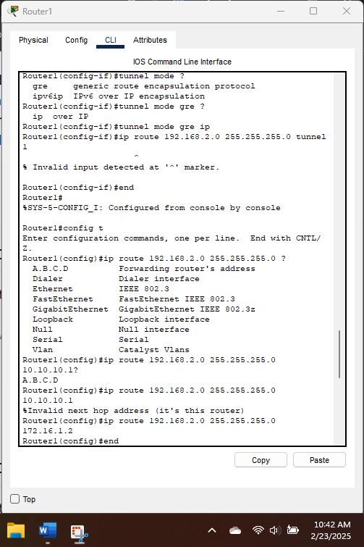

I Checked the status of the interface tunnel and make sure that traffic is flowing through the tunnel as expected.

